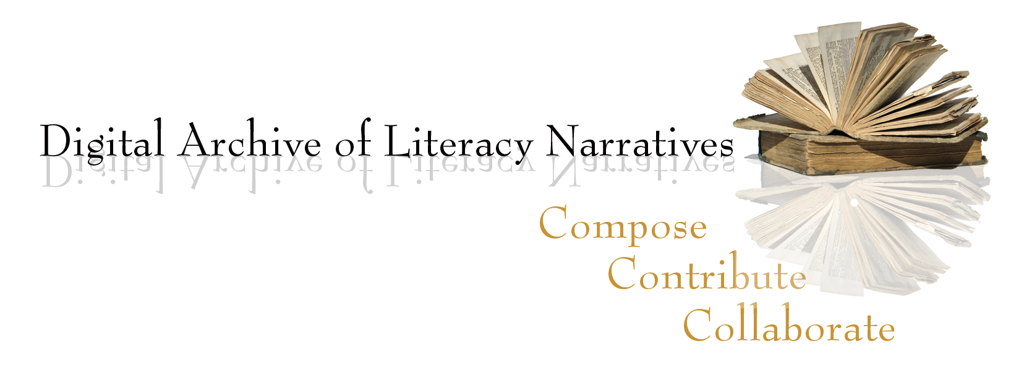

some DALN L2/ELL favorites

Annah Marzia Zaidi <http://daln.osu.edu/handle/2374.DALN/2170>
Kulsum Soonasra <http://daln.osu.edu/handle/2374.DALN/1082>
Tom Hong Do <http://daln.osu.edu/handle/2374.DALN/5223>
Hannah Keyung Lee <http://daln.osu.edu/handle/2374.DALN/436>
Yusuf Muhammed “Everyone has a Gift” <http://daln.osu.edu/handle/2374.DALN/539>
Sky Wang “Learn English as I Travel” <http://daln.osu.edu/handle/2374.DALN/933>
Deqa Mahammed “My Mother’s Struggle” <http://daln.osu.edu/handle/2374.DALN/592>
Viral Patel “Literacy Soundtrack <http://daln.osu.edu/handle/2374.DALN/913>
Sofia Gomez “Early Language Education” <http://daln.osu.edu/handle/2374.DALN/915>
Debleena Biswas “A Toast” <http://www.daln.osu.edu/handle/2374.DALN/417>
Anonymous “Literacy Narrative of a Deaf Korean Graduate Student”
<http://www.daln.osu.edu/handle/2374.DALN/22>

Randall Freisinger “Dead Language” <http://daln.osu.edu/handle/2374.DALN/105>
Keunho Shin “Studying with TV” <http://www.daln.osu.edu/handle/2374.DALN/920>

